H.T No
Regulations:
A15


Sreenidhi Institute of Science and Technology
(An Autonomous Institution)
Code No: 5AC07 Date: 11-May-2019 (AN)

B.Tech IV-Year I-Semester External Examination, May-2019 (Supplementary)
Control Systems (ECE)

Time: 3 Hours Max.Marks:75

Note: a) No additional answer sheets will be provided.
b) All sub-parts of a question must be answered at one place only, otherwise it will not be valued.
c) Missing data can be assumed suitably.

Part - A Max.Marks:25

Answer all QUESTIONS.

1. | Define Impulse response of a system. | [3M]
2. | What are the effects of PID controller? | [3M]
3. | What are the limitations of Routh’s stability? | [3M]
4. | Define Gain Margin and Phase Margin. Comment on the stability of the system when Gain Margin is positive and Phase margin is negative. | [3M]
5. | Write the transfer function of lag compensator and draw its pole zero plot. | [3M]
6. | A = 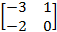 Determine state transition matrix e^{st}. | [2M]
7. | Find the steady state error for unit ramp for the following system 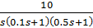 | [2M]
8. | State Routh’s stability criteria and use it to comment on a system whose characteristic equation is given by | [2M]
9. | Write about stability analysis using Nyquist plots. | [2M]
10. | A second order type-1, system has following constants K = 4, T₁ = 1, T₂ = 1/3.  Calculate for this system the value of gain margin. | [2M]
Part – B Max.Marks:50
ANSWER ANY FIVE QUESTIONS. EACH QUESTION CARRIES 10 MARKS.

11. | a) | Write the difference between open loop system and closed loop system with examples. | [5M]
 | b) | Determine the mathematical model of the mechanical system shown in Fig.1  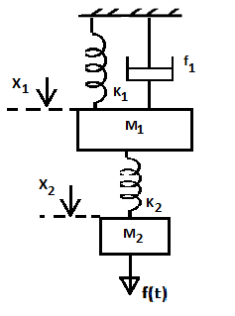Fig.1 | [5M]
12. | a) | For the unity feedback system having open loop transfer function  G(s) = 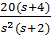;  Find i) Type of the system  ii) Error coefficients K_{p}, K_{v}, K_{a}  iii) Steady state error when input to the system is . | [5M]
 | b) | The closed loop transfer function of a second order system is given by  G(s) = 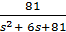  Determine rise time, settling time and peak overshoot. | [5M]
13. | a) | Determine the range of K for stability of unity feedback system with characteristic equation , using Routh stability criterion. For what value of K, will the system have sustained oscillations in the closed loop system. | [5M]
 | b) | The open loop transfer function of a unity feedback system is given by  G(s) = 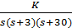 .  Sketch the root locus using the graph sheet provided and determine the value of K for ξ = 0.6. | [5M]
14. |  | Draw the Bode plot of the unity feedback control system, whose open loop transfer function is  G(s) = 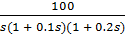  Also determine the gain margin, phase margin and stability. | [10M]
15. |  | Draw the complete Nyquist plot for a system with  G(s)H(s) =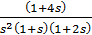  and also check the stability of the system. | [10M]
16. |  | The state model of a linear system is as follows  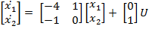 and 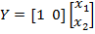  Find the transfer function of the system and draw the signal flow graph. | [10M]
17. |  | Find the expression for transfer function of armature controlled DC Servo Motor and draw its block diagram. | [10M]
18. |  | Write short notes on:
 | a) | Nyquist stability criterion | [5M]
 | b) | State Transition Matrix | [5M]
-- 00 -- 00 –

